Highropes resque

Petzl has brought the Jag Resque kit on the market. Especially for resques on structures and highropes. The system is very simple. Petzl has a hoist system with an ID attached to it, so that the lifeline / protection of the participant / victim can be relaxed and detached from the construction or safety line.
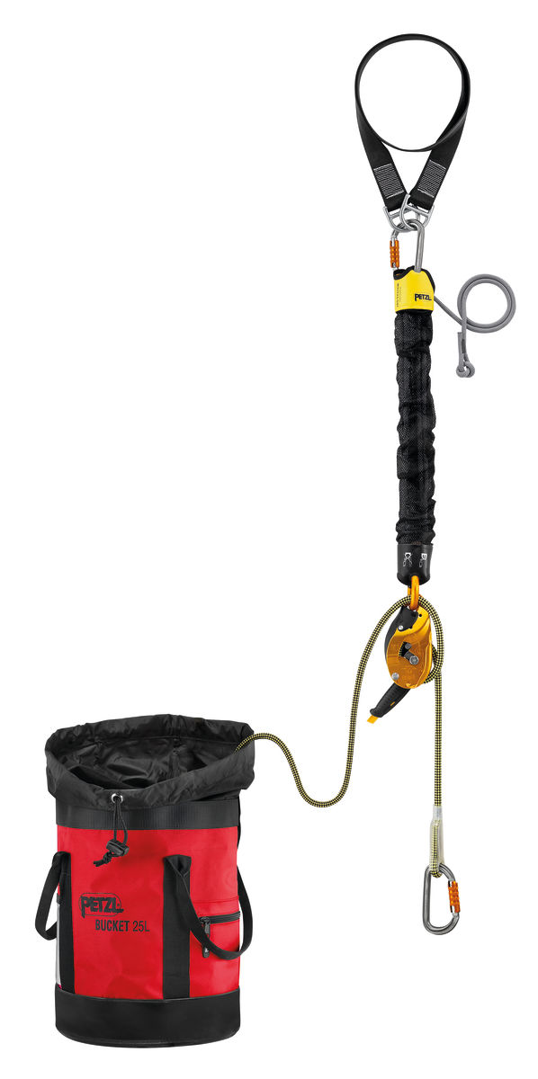
The set consists of a resquebag, a rope with a specific length, fastening carabiner, ID, hoist set with attachment carabiner and possibly an anchoring sling (not needed on the highropes but with constructions, for example industrual climbing). The costs are around 450 euros per set.

Manual resque kit
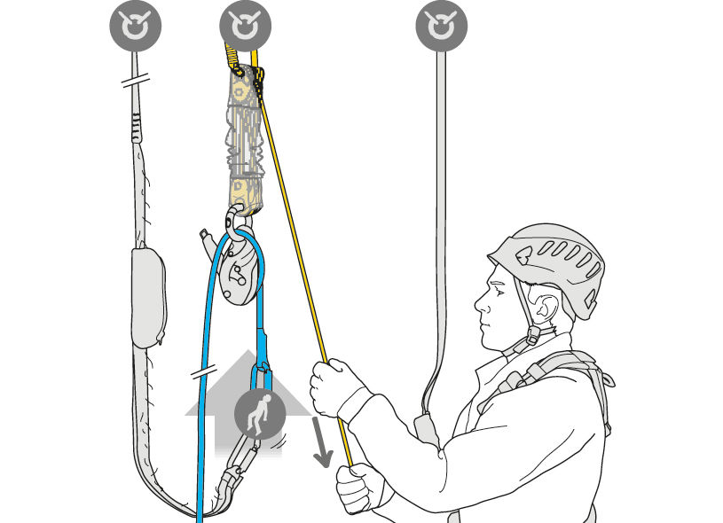
place the carabiner from the suspension point on the security cable of the highropes. Then throw the resque bag down and call "Below" as a warning. First look down if the job is free. Place the carabiner coming from the Id to the binding loop of the participant / victim. Then lift the victim up with the tackle set. During the hoist the rope of the hoist will automatically block. The voltage of the protection line of the participant / victim will thereby decrease, so that it can be disconnected from the steel cable.

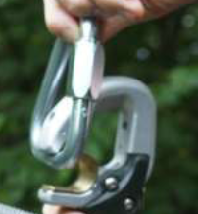
In order to get the Click-it system completely off the cable, we have to manipulate this security system. The first click-it can normally be removed from the cable, then hang it next to the participant / victim. Click this d.m. close the steel carabiner. The second klickit can now be removed from the steel cable in the same way. The click-it carabiner will open when you hold the steel carabiner against the magnet. Hang the second line next to the victim / participant.

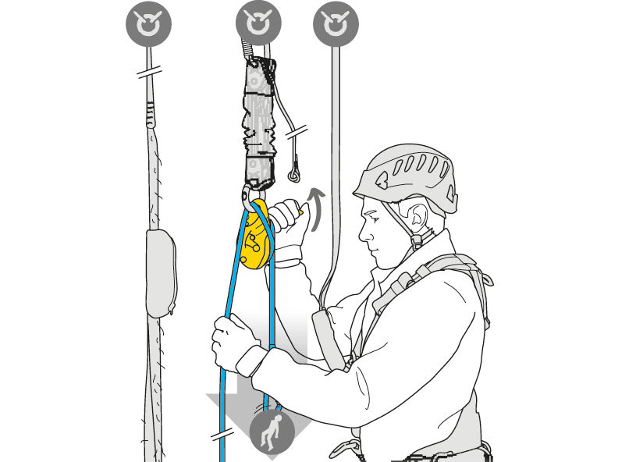
Then lower the victim / participant using the ID. Guide the ID with two hands as shown in the picture.
When the ID is fixed you must first unblock it. When the victim is down, he / she may detach from the rope. The carabiner remains attached to the rope.

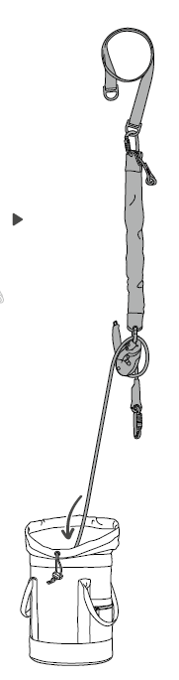
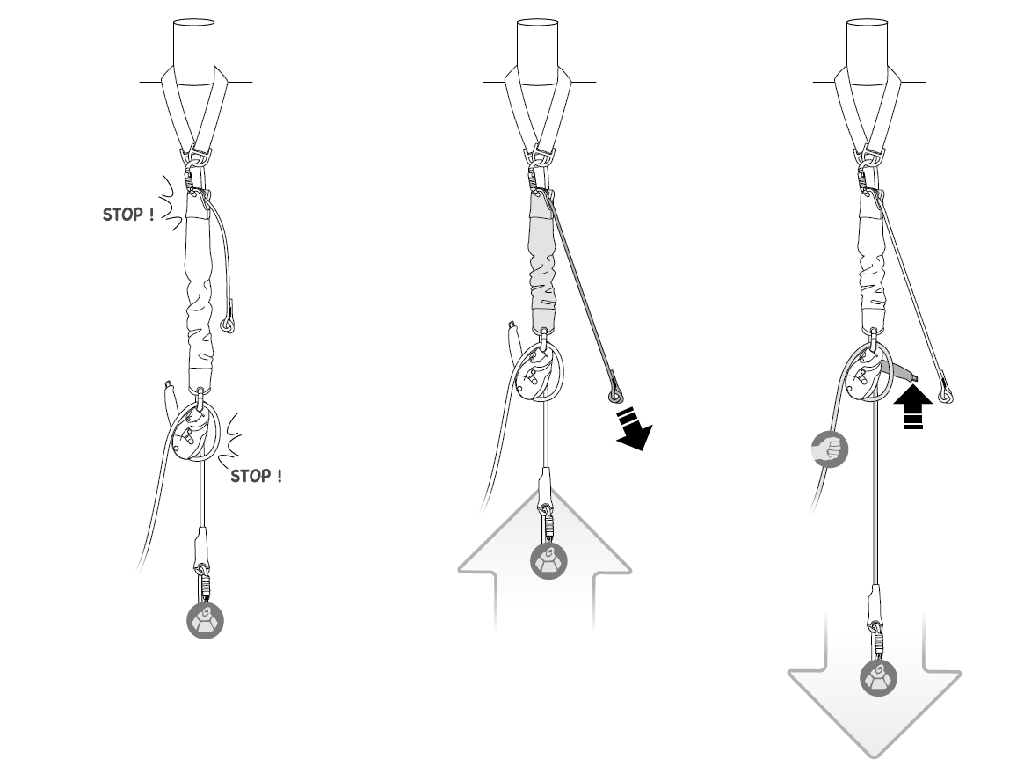
There are two braking systems on the yoke. The first d.m. a traxion at the top of the hoist and the other is in the ID. Always ensure that the rope is tight between the ID and the participant. Then lift the victim up. To lower the participant, move the handle of the ID upwards. Guide the rope well so that lowering is smooth and not by shocks.

Reset the system after resque
After using the resquekit you have to relax and extend the lifting system again. Also the rope that comes from the ID you must bring back to an acceptable length.
.
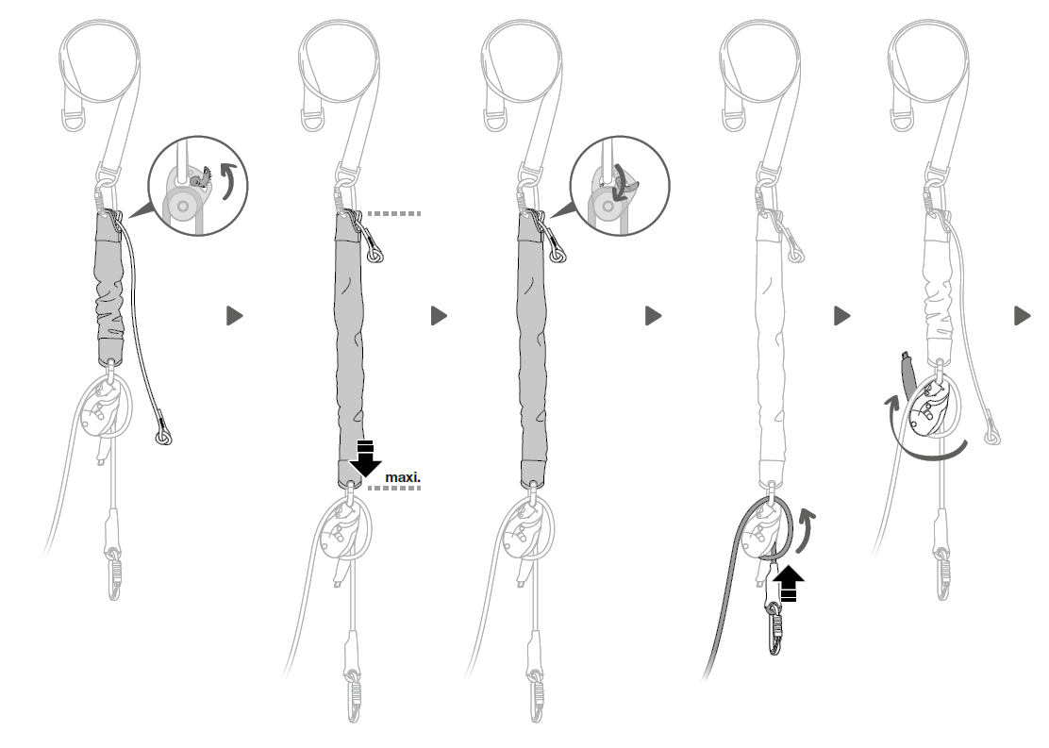
To unblock the hoist you get the red handle of the traxion up. After removing the hoist, replace this red lever. Unblock the ID and shoot the rope neatly in the rope bag.

